**Requirements:**

**Functional:**

1. **U**ser giving long URL as input. Service should generate short URL with fewer characters from longer URL
2. When user access short URL, service should redirect to original link

**Non-Functional:**

1. Highly available
2. Response time from server has to be faster

**APIS:**

1.creating short URL API

**Method:** POST

**Route:** /createShortURL

**Full Route:** http://localhost:8102/createShortURL

**Type:** Text

**Description:** Get short URL by passing long URL in request body

2.Redirect to original URL by passing tiny URL in API

**Method:** GET

**Route:** /{shortURL}

**Full Route:** http://localhost:8102/{shortURL}

**Description:** Redirecting to original URL by hitting with short URL

**Database Design:**

1. NOSQL(MongoDB) is used to store more data. Relational database is expensive, and scaling is not easy in storing Tera bytes of data. MongoDB can be scaled using sharding key at cluster level. It is easy to scale horizontally. Below commands are used after installing mongoDB

show dbs;

use local;

db.createCollection("mapurl")

1. Redis is used as cache store in retrieving original URL if it is present for given short URL

**Design and Algorithm:**

1. Creating short url



1. Accessing original url

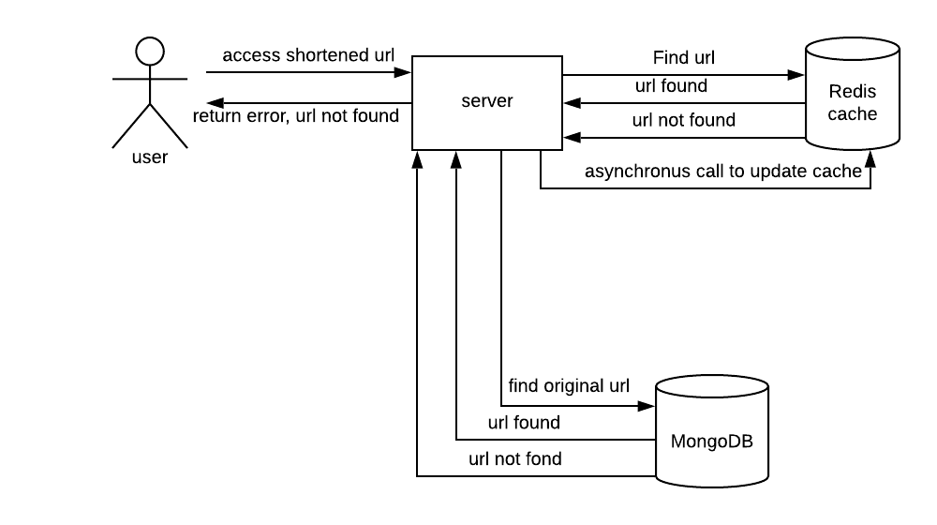

1. High Level Architecture



**Trouble shooting steps:**

Anudeeps-MacBook-Pro:usr anudeep$ mongo

MongoDB shell version v4.2.3

connecting to: mongodb://127.0.0.1:27017/?compressors=disabled&gssapiServiceName=mongodb

2020-02-17T21:35:58.430-0500 E QUERY [js] Error: couldn't connect to server 127.0.0.1:27017, connection attempt failed: SocketException: Error connecting to 127.0.0.1:27017 :: caused by :: Connection refused :

connect@src/mongo/shell/mongo.js:341:17

**Solution:**

mongod --config /usr/local/etc/mongod.conf --fork